Little Acorns Menu Week 1
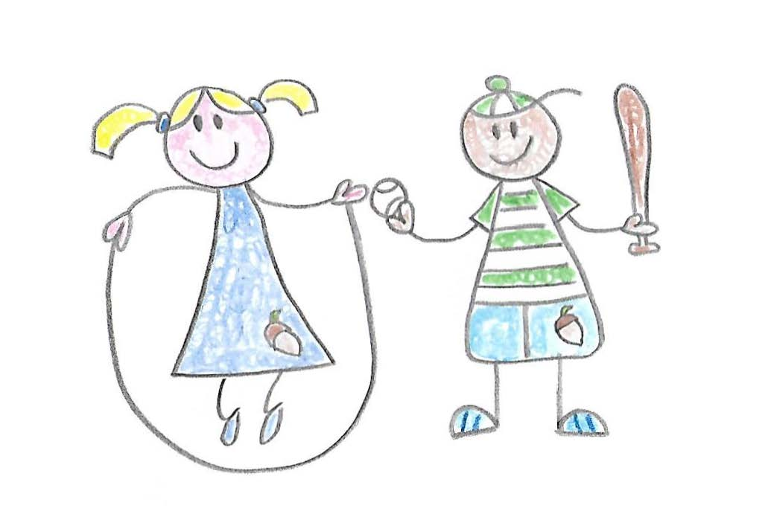

Monday | Tuesday | Wednesday | Thursday | Friday
Wholegrain cereal  Fruit | Wholegrain cereal  Fruit | Wholegrain cereal  Fruit | Wholegrain cereal  Fruit | Wholegrain cereal  Fruit
Breadsticks/  Crackers | Wholegrain Crackers | Breadsticks/  Crackers | Oatcake | Wholegrain  Crackers
Spaghetti bolognaise with wholegrain pasta (with fresh tomatoes and sweetcorn) | Cauliflower mac and cheese with salad | Mixed bean and root vegetable soup (with 2 portions of veg per bowl) with wholemeal bread | Baked cheese and tomato and pepper risotto | Posh fish fingers, chips and peas and sweetcorn
Fruit break | Fruit break | Fruit break | Fruit break | Fruit break
Afternoon Tea  Beans on toast with cheese | Afternoon Tea  Chicken pitta with carrot sticks | Afternoon Tea  Homemade hummus, pasta twists carrot sticks, chopped peppers and yoghurt dip | Afternoon Tea  Salmon tacos with wholemeal wraps, cucumber and celery sticks | Afternoon Tea  Ham sandwiches with chopped apple, carrot sticks and yoghurt dip

