Little Acorns Menu Week 3
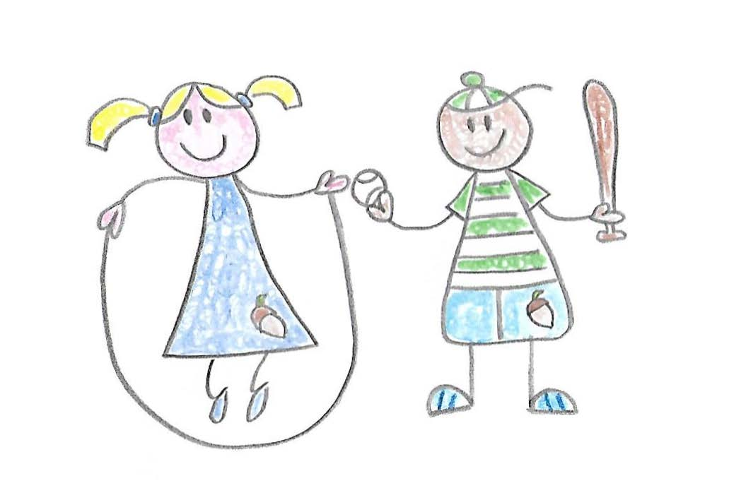

Monday | Tuesday | Wednesday | Thursday | Friday
Wholegrain cereal  Fruit | Wholegrain cereal  Fruit | Wholegrain cereal  Fruit | Wholegrain cereal  Fruit | Wholegrain cereal  Fruit
Breadsticks/  crackers | Oatcake | Breadsticks/crackers | Wholemeal cracker | Oatcake
Lean beef meatballs with wholemeal pasta (with fresh tomato, pepper and sweetcorn) | Pea Curry with rice | Slow cooked fajitas with wholemeal wraps with salad | Chicken with mushroom and crème fraiche with wholegrain rice and peas. | Fish fingers, chips, peas and salad
Fruit break | Fruit break | Fruit break | Fruit break | Fruit break
Afternoon Tea  Beans on toast with cheese | Afternoon Tea  Chicken pitta with carrot sticks | Afternoon Tea  Homemade hummus, pasta twists carrot sticks, chopped peppers and yoghurt dip | Afternoon Tea  Salmon tacos with wholemeal wraps, cucumber and celery sticks | Afternoon Tea  Ham sandwiches with chopped apple, carrot sticks and yoghurt dip

